X. Financial Aspects

Over the past decade, the increase in the number of internet users and the advent of the Internet of Things (IoT) has led to the financial aspects of cyber security gaining importance. Cyberattacks and the related security measures have two primary financial aspects: the losses due to attacks and the cost incurred while implementing countermeasures.

X.1 The Losses

This section discusses the financial losses suffered by individuals, business outfits and companies through cybercrimes. The section will describe the Types and Quantity of scams in individual sections.

X.1.1 Types

Most forms of modern cybercrimes involve stealing data, mainly personal account details, from both consumers and the institutions which store them, like banks and IT companies. Many scams are targeted towards individuals who are unaware which include not only children and the elderly, but also CEOs of companies and important government officials. The most common form is phishing in which the attacker tries to obtain sensitive information like usernames and passwords by posing as a trusted individual over electronic communication software, usually email. An example is given in Figure 1.

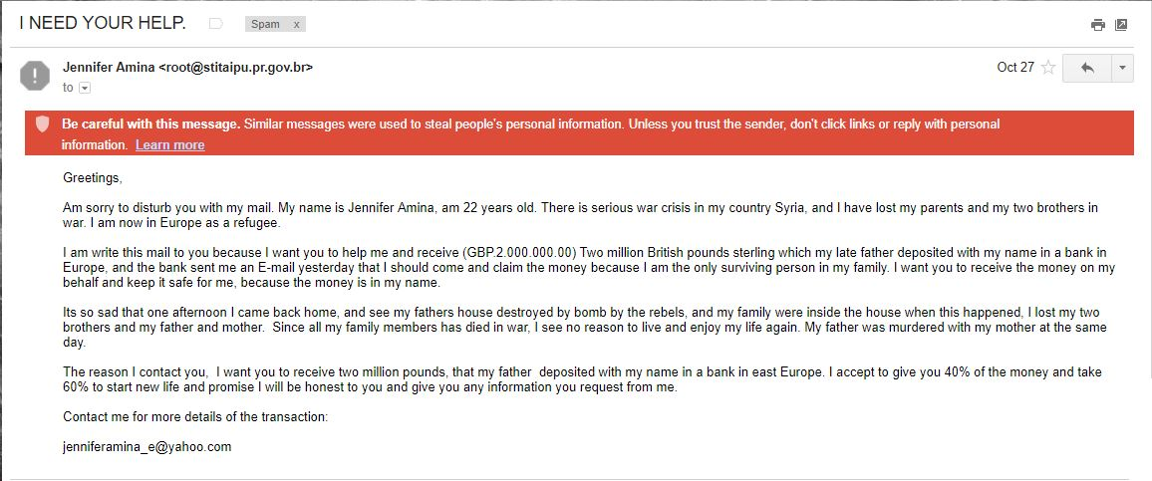

Figure 1 An example of a phishing email.

Using the information obtained, the attacker is quite easily able to raid accounts and exploit credit cards.

Recently, these attackers have become bolder and have tried to attack not only individuals with bank accounts, but also the banks themselves. [1].

Another scam is termed as Business Email Compromise (BEC), involves scammers emailing employees, posing as the boss of the company and demanding transfers of large sums of money.

Ransomware is also a widely used scamming software which was in the news recently for affecting many people across the globe. The software locks down the affected server and does not release the information until a ransom has been paid. According to Internet Security Threat Report (Symantec, 2017, p8) the average ransom amount increased from $294 in 2015 to $1077 in 2016, an increase of 266%. And, with 4,63,841 detections in 2016, that brings the total losses to nearly $50 crore.

X.1.2 Quantity

The average global annual cost of cybercrimes acquired from Cost of Cyber Crime Study (Ponemon Institute, 2017, p12) is given in the following graph:

From the graph, it can be observed that in the recent years, the average annual expenditure has seen a significant increase. While the cost of cybercrimes had been relatively stagnant in the period 2013-15, the sudden increase in internet accessibility and the shift of developing countries like India towards online, cash-less transactions could be the reason for the sudden change in 2015-16. Crimes of a larger magnitude, like attempting to steal money directly from banks can also be a reason for the observed rise, especially in 2017.

Figure Cost of Cybersecurity

The loss to an individual, can vary widely, depending on the type of scam, access granted to scammers, vigilance and pre-existing security measures. While implementing security software like antiviruses is a solution, they are not always easily accessible, cheap or effective.

X.2 Costs Incurred

Many users consider a paid antivirus software as an unnecessary investment. Most people owning an antivirus software have the free or trial version, which does not include all features. Figure 3 shows the non-discounted prices of five popular antivirus software used in India. The prices have been obtained from the respective websites and have been scaled down (when required) to the cost of buying the software for one device for a year-long license.

From Figure 3, we can see that Kaspersky, Norton and McAfee market the same software for both PCs and mobile devices. This can be an advantage for those requiring protection for a large number devices as it is more convenient to buy a single software for all devices. However, Bitdefender and QuickHeal market separate software and are thus able to reduce the price of their antivirus for mobile phones. Apart from Kaspersky, who have lower prices for both interfaces, when a company markets a single software, the price is between that of the two separate software.

McAfee provides a single software for all types of devices. It is cheaper than most of the comparable PC antivirus software available in the market. Although the software is costlier than most mobile protection software, it is a widely trusted software in India due to its easy to use interface, consumer-friendly offers and large vulnerability coverage.